**PROJECT REPORT TEMPLATE**

THE TABLEAU: ANALYSING HOUSING PRICES IN METROPOLITAN AREA OF INDIA

TEAM LEADER: RENSIYA GRACY M

TEAM MEMBERS: HARISHKUMAR S

VASU S

DHILEEPAN S L

1.**INTRODUCTION**

The analysis of housing prices in metropolitan areas of India is a crucial study aimed at understanding the dynamics of the real estate market in some of the most densely populated and economically significant regions in the country. This research seeks to delve into the various factors that influence housing prices, their trends over time, and the implications for both homeowners and the broader economy.

* 1. **OVERVIEW**

Metropolitan areas in India, such as Mumbai, Delhi, Bengaluru, and Chennai, have witnessed substantial growth in their real estate markets. These regions attract a diverse population due to job opportunities, educational institutions, and cultural diversity. Consequently, housing prices in these areas have become a significant concern for residents and potential buyers.

The study will encompass a comprehensive analysis of housing prices in these metropolitan areas, considering factors such as location, property type, demand and supply, economic indicators, and policy influences.

* 1. **PURPOSE**

Inform Decision-Making: By shedding light on the factors driving housing price fluctuations, this study aims to provide valuable insights for potential homebuyers, real estate investors, and policymakers. It will help individuals make informed decisions about their housing investments and assist policymakers in formulating strategies to address housing affordability and market stability.

**2. PROBLEM DEFINATION & DESIGN THINKING**

**2.1 EMPATHY MAP**

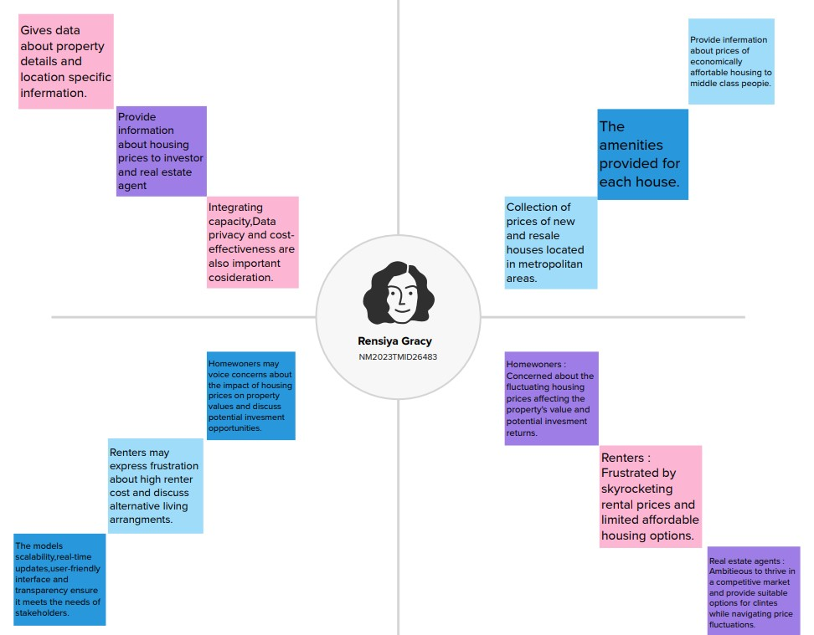

**2.2 IDIEATION & BRAINSTROMING MAP**

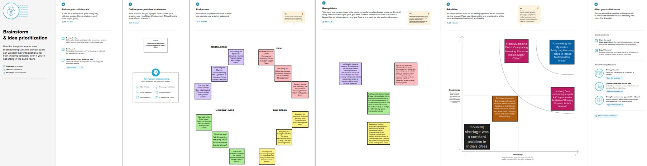

**RESULT**

**DASHBOARD**

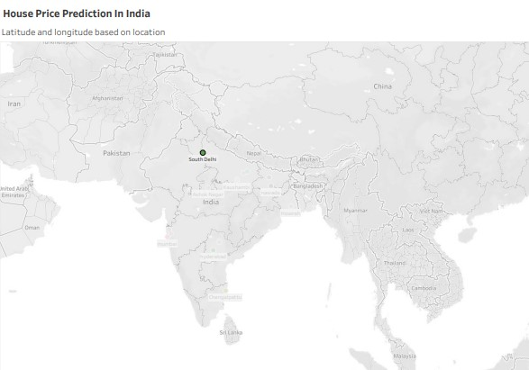

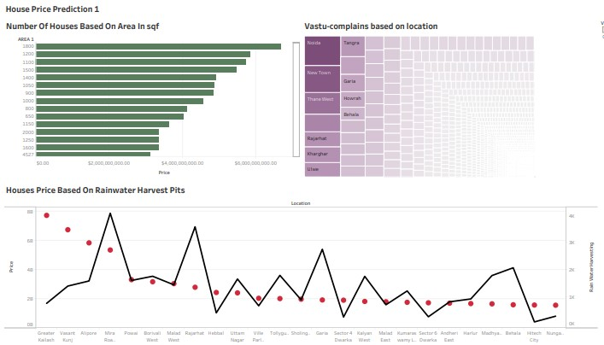

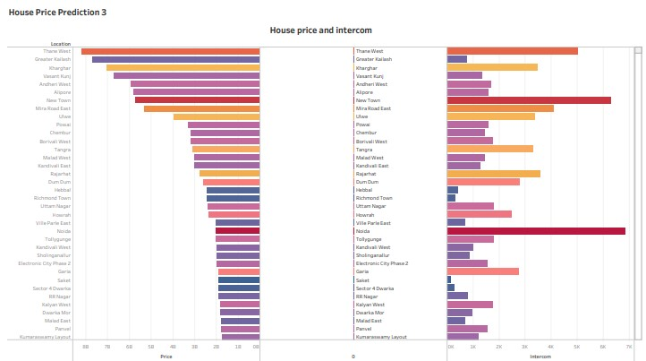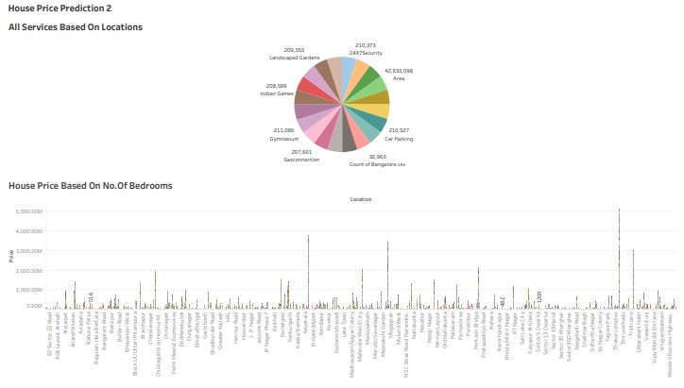

**STORY**

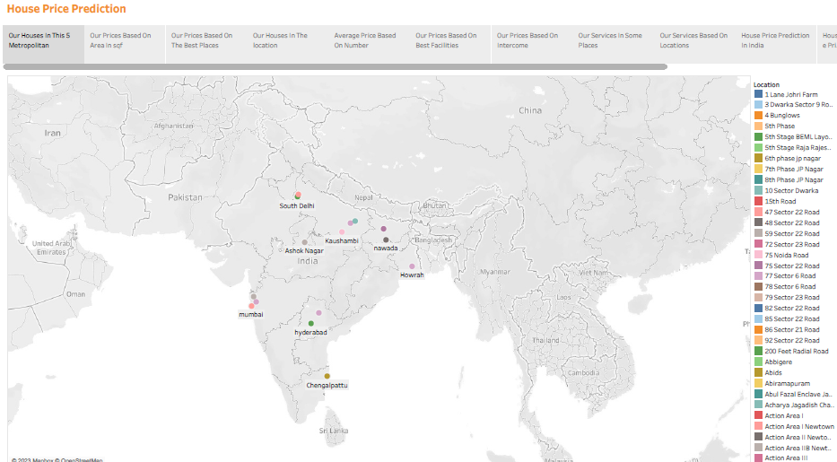

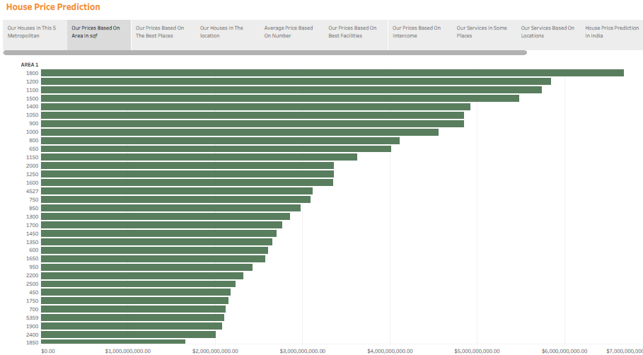

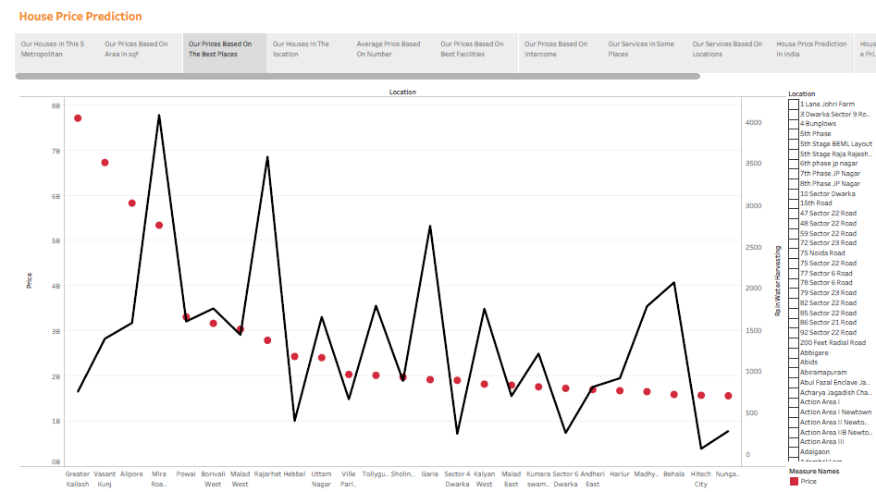

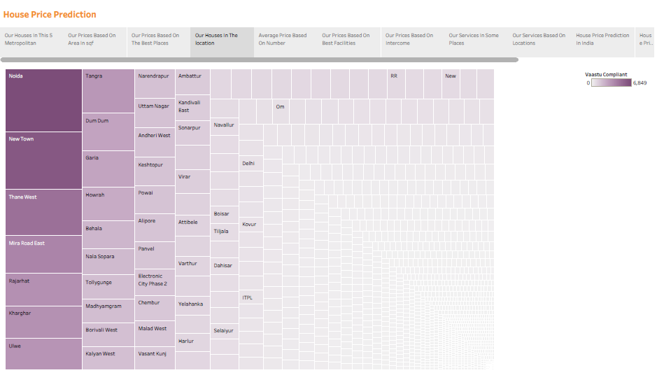

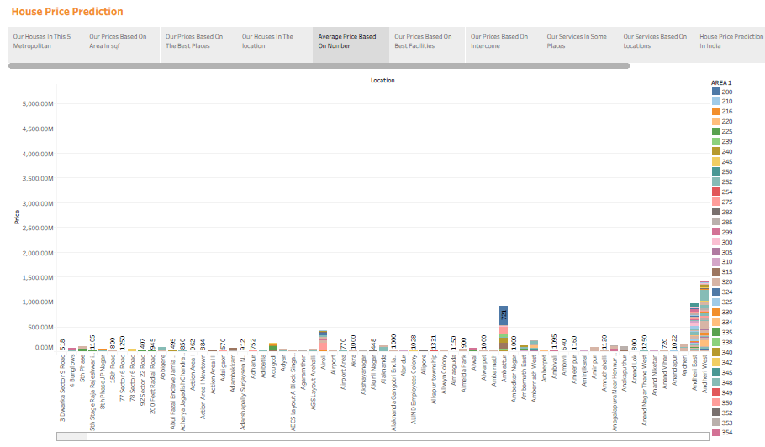

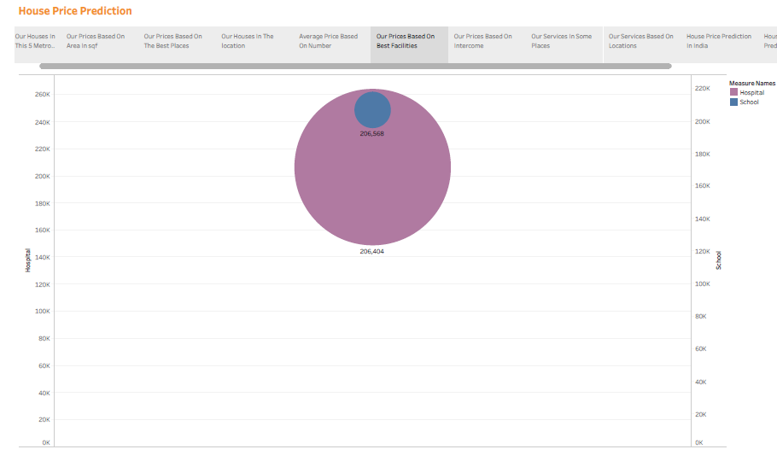

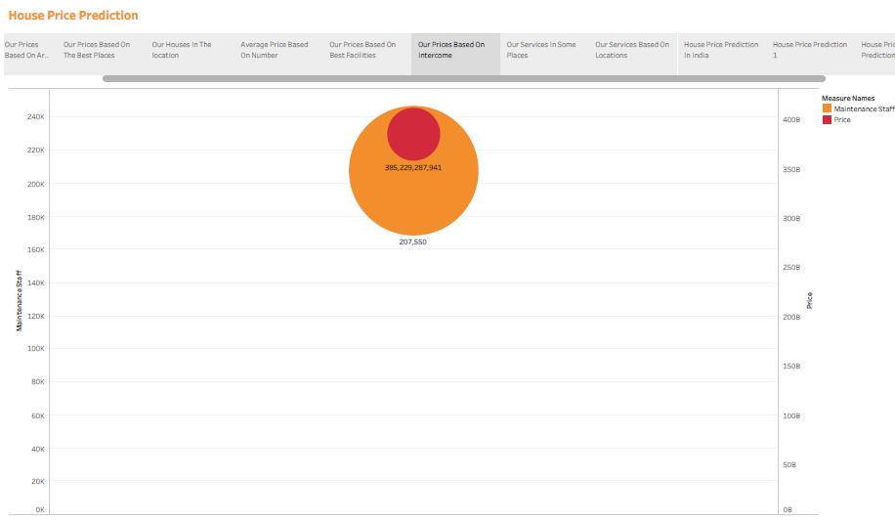

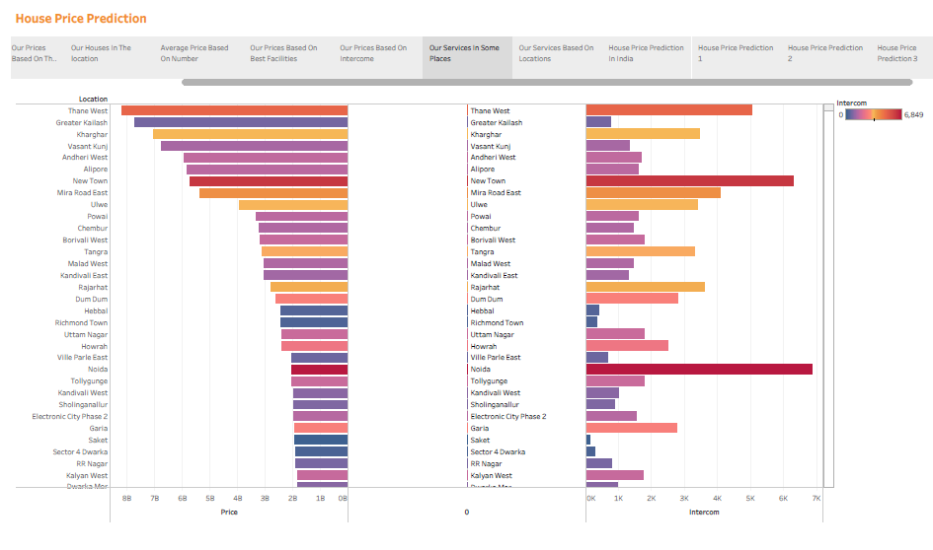

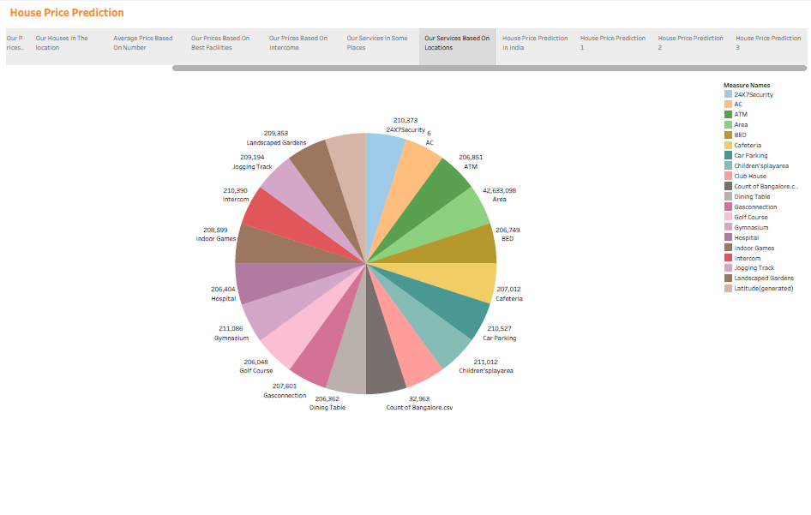



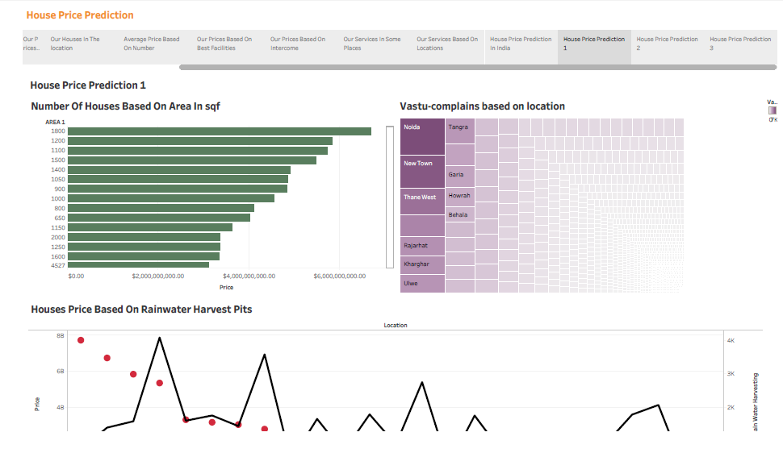

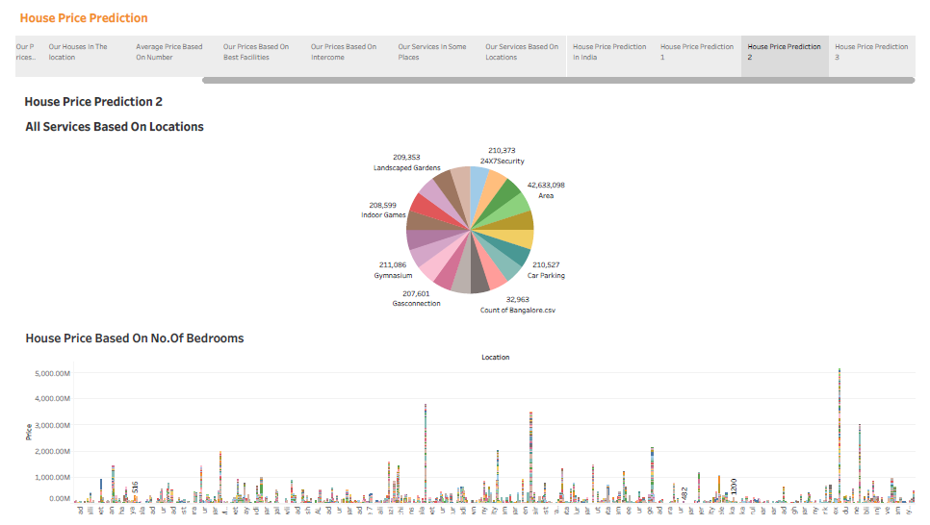



**ADVANTAGES**

**1.Investment Opportunities: It helps potential buyers and investors make informed decisions on where to invest in real estate, potentially leading to profitable opportunities.**

**2.Market Trends: Understanding housing prices reveals market trends, enabling buyers and sellers to time their transactions for the best outcomes.**

**3.Government Policies: Knowledge of housing prices can help citizens and policymakers assess the effectiveness of government policies aimed at affordable housing and urban development.**

**4.Economic Indicators: Housing prices are often indicative of the overall economic health of a region or city, as they affect and are affected by employment opportunities and income levels.**

**5.Quality of Life: Examining housing prices helps assess the quality of life in different metropolitan areas, considering factors like amenities, education, and healthcare access.**

**DISADVANTAGES**

**1.Data Quality: Data on housing prices may not always be accurate or up-to-date. Official sources can have discrepancies, and real estate transactions often go unreported.**

**2.Heterogeneity: Metropolitan areas in India are diverse, and housing markets vary greatly by location. A one-size-fits-all analysis may not capture these differences.**

**3.Lack of Transparency: The real estate market in India can be opaque, with limited information available about transactions, making it challenging to gain a comprehensive view.**

**4.Rapid Market Changes: Housing prices in metropolitan areas can change rapidly, making it difficult to predict future trends accurately.**

**5.Factors Beyond Price: Housing decisions involve factors beyond price, like infrastructure, amenities, and quality of life, which are difficult to quantify.**

**APPLICATION**

**1.Data Collection:**

**Gather data on housing prices, including historical data, location, size, type, and features of properties.**

**Collect demographic and economic data for the metropolitan areas.**

**2.Data Preprocessing:**

**Clean and prepare the data by handling missing values and outliers.**

**Geocode property locations for mapping and spatial analysis.**

**3.Exploratory Data Analysis (EDA):**

**Visualize data to identify trends, patterns, and correlations.**

**Explore housing price distributions and variations in different areas.**

**4.Feature Engineering:**

**Create new features like price per square foot, distance to amenities, or neighborhood indicators.**

**Encode categorical variables and normalize numerical features.**

**CONCLUSION**

**1.Rising Demand: Housing prices in Indian metros have been on an upward trajectory due to the increasing urbanization and population growth. This trend is likely to continue.**

**2.Location Matters: Proximity to employment hubs, educational institutions, and transportation infrastructure significantly influences housing prices. Prime locations command higher rates.**

**3.Affordability Gap: There is a growing gap between housing prices and the average income of residents in many metropolitan areas, making it challenging for many to buy homes.**

**4.Speculation and Investment: Real estate in metros often attracts investors, leading to speculative activities that can drive up prices in the short term.**

**5.Supply and Demand Dynamics: Understanding the supply and demand dynamics of the specific metropolitan area is crucial for predicting future price trends.**

**FUTURE SCOPE**

**1.Data Analytics: Continued data collection and analysis to identify trends and factors influencing housing prices, helping buyers, sellers, and policymakers make informed decisions.**

**2.Predictive Modeling: Developing predictive models using machine learning and AI to forecast future housing price trends and assess potential risks and opportunities.**

**3.Policy Development: Collaborating with government bodies to create housing policies that promote affordability and sustainable urban development.**

**4.Real Estate Technology: Innovation in real estate technology, such as virtual tours, online property databases, and blockchain-based transactions, to enhance the industry's efficiency.**

**5.Sustainable Housing: Addressing environmental concerns by promoting green building practices and eco-friendly housing options.**